WEEK 2:

1.
public PerformOperation isOdd() {
return (int a) -> a % 2 != 0;
}
public PerformOperation isPrime() {
return (int a) -> {
if (a <= 1) return false;
if (a == 2) return true;
if (a % 2 == 0) return false;
for (int i = 3; i <= Math.sqrt(a); i += 2) {
if (a % i == 0) return false;
}
return true;
};
}
// Lambda for palindrome check
public PerformOperation isPalindrome() {
return (int a) -> {
String s = String.valueOf(a);
return new StringBuilder(s).reverse().toString().equals(s);
}
}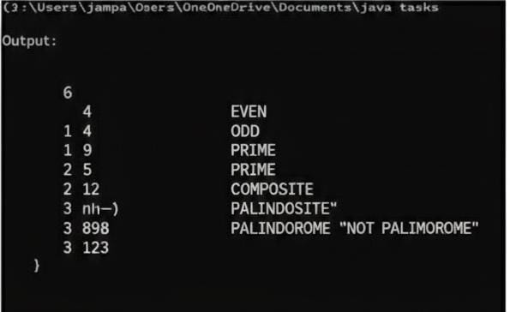

RESULT: Thus,the lamda fune function for odd/odd, a checks execute successfully

2.
public static void miniMaxSum(List<Integer> arr) {
long total = 0;
int min = arr.get(0);
int max = arr.get(0);
for (int num : arr) {
total += num;
if (num < min) min = num;
if (num > max) max = num;
}
long minSum = total - max;
long maxSum = total - min;
System.out.println(minSum + " " + maxSum);
}
}
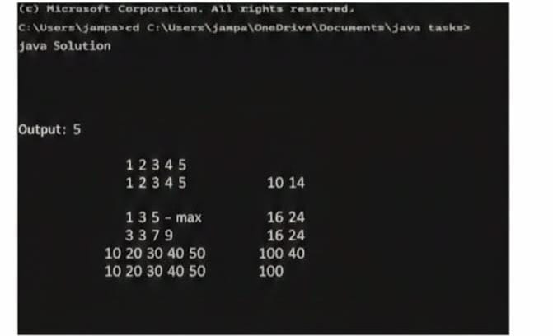

RESULT: Thus, The mini-max sum function executes successfully .

3.
import java.io.*;
import java.util.*;
class UserMainCode
{
public int isPalindrome(String input1){
String lower = input1.toLowerCase();
String reversed = new StringBuilder(lower).reverse().toString();
if (lower.equals(reversed)) {
return 2; // Palindrome
} else {
return 1; // Not a palindrome
}
}
}

RESULT: Thus ,Palindrome function executes successfully.

4.
import java.io.*;
import java.util.*;
class UserMainCode
{
public int allDigitsCount(int input1){
return String.valueOf(input1).length();
}}

class Result {
public static String findDay(int month, int day, int year) {
Calendar cal = new GregorianCalendar(year, month - 1, day);
String[] days = { "SUNDAY", "MONDAY", "TUESDAY", "WEDNESDAY", "THURSDAY", "FRIDAY", "SATURDAY" };
return days[cal.get(Calendar.DAY_OF_WEEK) - 1];
}
}

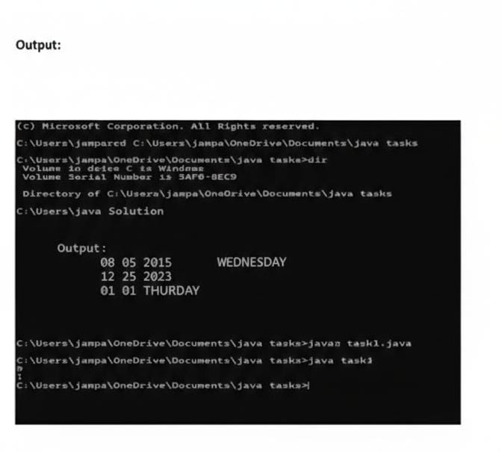
RESULT: Thus,to find a Day function executes successfully.

5.
import java.io.*;
import java.util.*;
class UserMainCode
{
public int totalHillWeight(int input1, int input2, int input3){
int totalWeight = 0;
int currentWeight = input2;
for (int level = 1; level <= input1; level++) {
totalWeight += level * currentWeight;
currentWeight += input3;
}
return totalWeight;
}
}
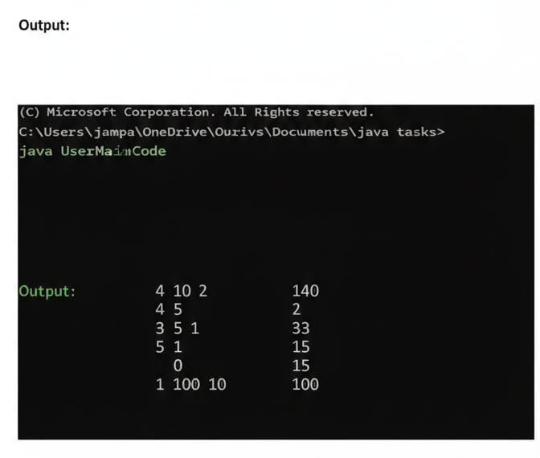

RESULT : Thus ,the total Hill weight function executes successfully.

6.
class UserMainCode {
public int sumOfSumsOfDigits(int input1) {
String numStr = String.valueOf(input1);
int totalSum = 0;
for (int i = 0; i < numStr.length(); i++) {
int partialSum = 0;
for (int j = i; j < numStr.length(); j++) {
partialSum += Character.getNumericValue(numStr.charAt(j));
}
totalSum += partialSum;
}
return totalSum;
}
}
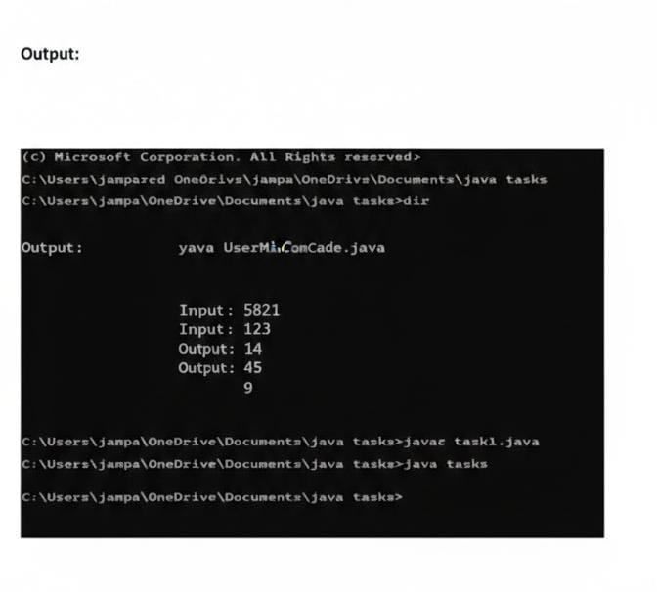
RESULT : Thus the “Sum Of Sums” function executes sucessfully.

